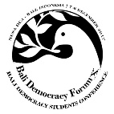
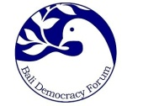
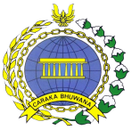
Bali Democracy Students Conference (BDSC)
Nusa Dua, Bali, 5 – 6 December 2019
APPLICATION FORM
Personal Information
- Full Name : ……………………………………………………………………………………………………..
- Place of Birth : ……………………………………………………………………………………………………..
- Date of Birth : ……………………………………………………………………………………………………..
- Gender : ……………………………………………………………………………………………………..
- Nationality : ……………………………………………………………………………………………………..
Contact Details
- Address : ……………………………………………………………………………………………………..
..........................................................................................................
- Mobile No. : ……………………………………………………………………………………………………..
- Phone No. : ……………………………………………………………………………………………………..
- Email : ……………………………………………………………………………………………………..
- Social media account : ……………………………………………………………………………………………………..
(for profile video link)
University Data
- University : ……………………………………………………………………………………………………..
- Address of University : ……………………………………………………………………………………………………..
- Faculty : ……………………………………………………………………………………………………..
- Major/Department : ……………………………………………………………………………………………………..

Are you interested to be Chair or Speaker during the Panel Discussion Session? Yes No

Place and date …………………………………
Signature …………………………………
Applicant’s Name …………………………………

